**LRS Proposal Cycle12 Specification**

Low Resolution Spectrograph Mark III specification

* Spectrum domain 400 - 800 nm
* Observation mode: Slitless and Long slit
* Spectrum Resolution: R~250-750
* Slit size:
  1. Slit A: mechanical width 100 micron, mechanical length 20 mm

          On-sky angular width 2 arcsec, On-sky angular length 2 arcmin

* 1. Slit B: mechanical width 1,000 micron, mechanical length 20 mm

          On-sky angular width 5 arcsec, On-sky angular length 2 arcmin

* Plate scale 0.2 arcsec
* Main Detecter specification:
  1. Model: Newton Andor DU920 BEX2-DD
  2. Array size: 1024x 255
  3. Pixel size: 26 x 26 micrometer

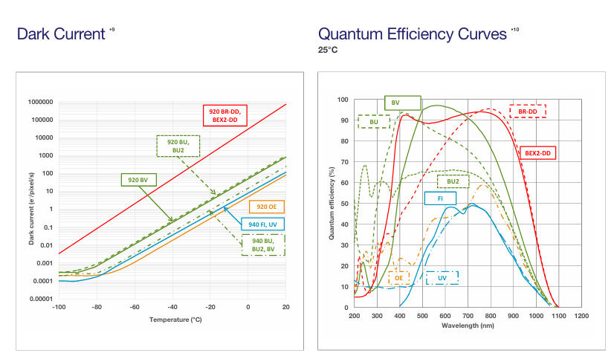

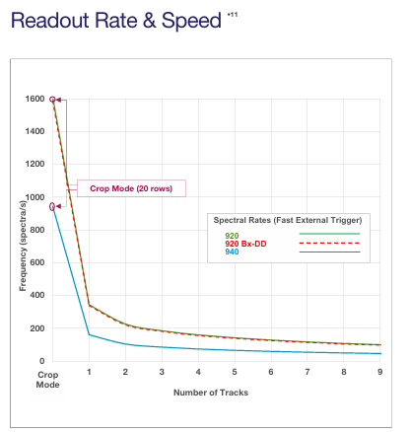

* Guiding Unit specification

1. Pickoff mirror
2. Model: ZWO ASI6200MM Pro(mono)
3. Full frame 36 x 24 mm
4. CMOS Sensor IMX455
5. Pixel Size 3.76 micron
6. Read noise 1.2e-3.5e
7. Resolution 9576 x 6388
8. Spectrograph FOV 3 arcmin

* Guiding Unit FOV
* Panda controller: specification and software interface

1. Calibration source: Cal3:Tungsten, Cal2: HgAr and Cal1: Neon (Spectral technology instrument company)
2. Sliding rail control: Grism position, Slit mode, and Calibration mode
   1. Software interface: 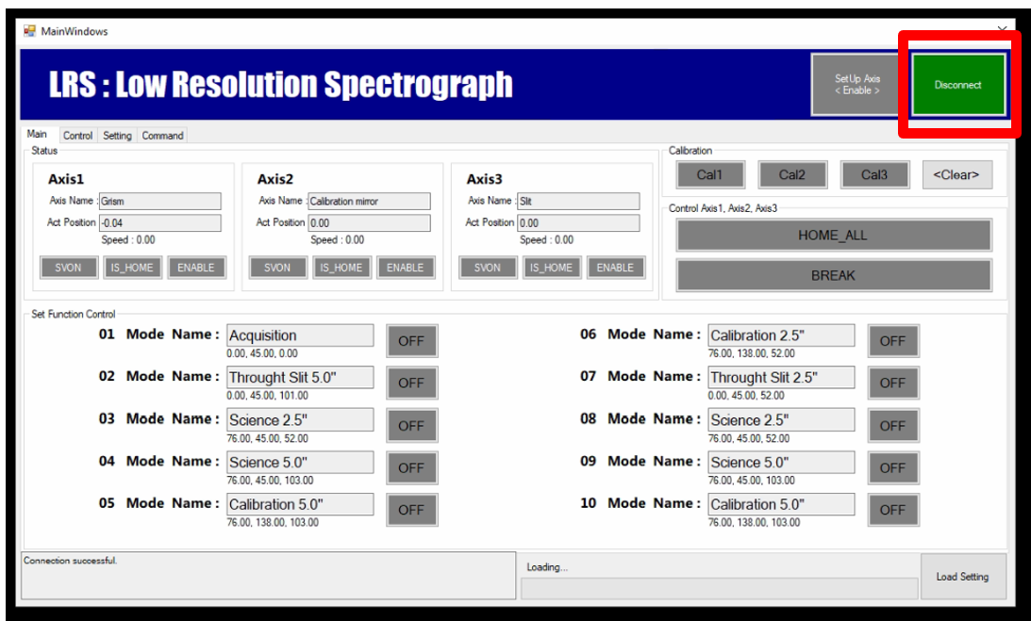

* Interface MaximDL and ASI studio